**Record of Ex. No: 4 –Orthographic Multi-view Projections**

**Date of experiment:** 06.05.2021 **Date of submission:** 06**.05**.2021

**Name:** Kunal Keshan S **Department:** ECE – A **Roll No:** RA2011004010051

**Aim:**

To learn and understand orthographic multi-view projections with straight lines and 2D figures.

**Software used:** AutoCAD.

**Procedure:**

|  |  |
| --- | --- |
| Commands Used | Purpose of Command |
| UNITS | To set the units of the drawings. |
| LIMITS | To set the limits of the drawing area. |
| ZOOM | To adjust the view of the drawing area. |
| LINE | Used to draw a line. |
| POINT | Used to place a point on the drawing area. |
| TEXT | Used to add text in the drawing area. |
| TEXTEDIT | Used to edit any existing text. |
| DIMLINEAR | Used to add linear dimensions. |
| DIMALIGNED | Used to add aligned dimensions(i.e parallel to a line or point that is not perpendicular) |
| DIMANGLE | Used to add dimensions between any two lines or arcs. |
| DDPTYPE | Used to set the type of point and its size. |
| POLYGON | Used to draw a polygon of required number of sides, either inscribed in a circle or the circle in the polygon. Or the polygon can be drawn with respect to its edge length. |
| TRIM | Used to trim off unnecessary parts of the drawing. |
| CIRCLE | Used to draw of circle of desired radius. |

**Steps:**

1. Adjust the right units and limits of the drawing area using UNITS AND LIMITS.
2. Draw a line XY of appropriate length and label above the line as V.P. and below the line as H.P.
3. Now depending on the question, the V.P. usually represents the front view and the H.P. usually represents the top view of a point, line or an object in the case of a FIRST ANGLE PROJECTION.
4. After marking the points and the lines, label the points and give them dimensions using TEXT and DIMLINEAR, DIMALIGNED and DIMANGLE.
5. Use the CIRCLE command to make use of the ROTATING CIRCLE METHOD to draw the projection of a line at different angles with respect to both the V.P. and the H.P.

**Projection of Lines:**

**Question 1:**  A line AB, of length 70mm long, is inclined at 45° to HP and 30° to VP. Its end A is 20 mm above HP and 25mm in front of VP. Draw its projections.

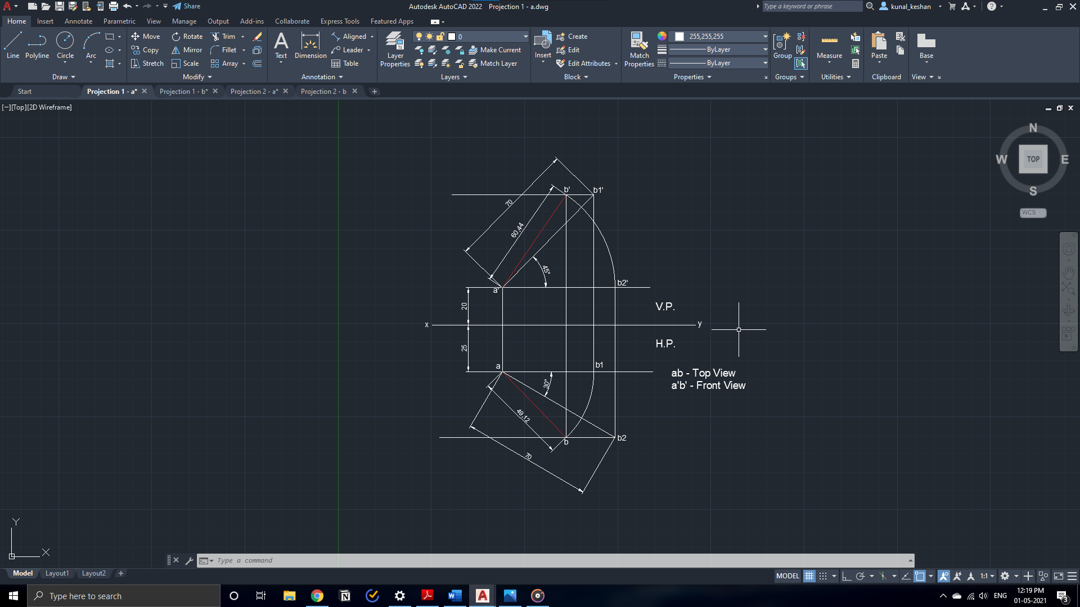

**Question 2:** A line CD 80mm long has its end C 30 mm above HP and 20 mm in front of VP. The line is inclined 45° to HP and 35° to VP. Draw its projections.

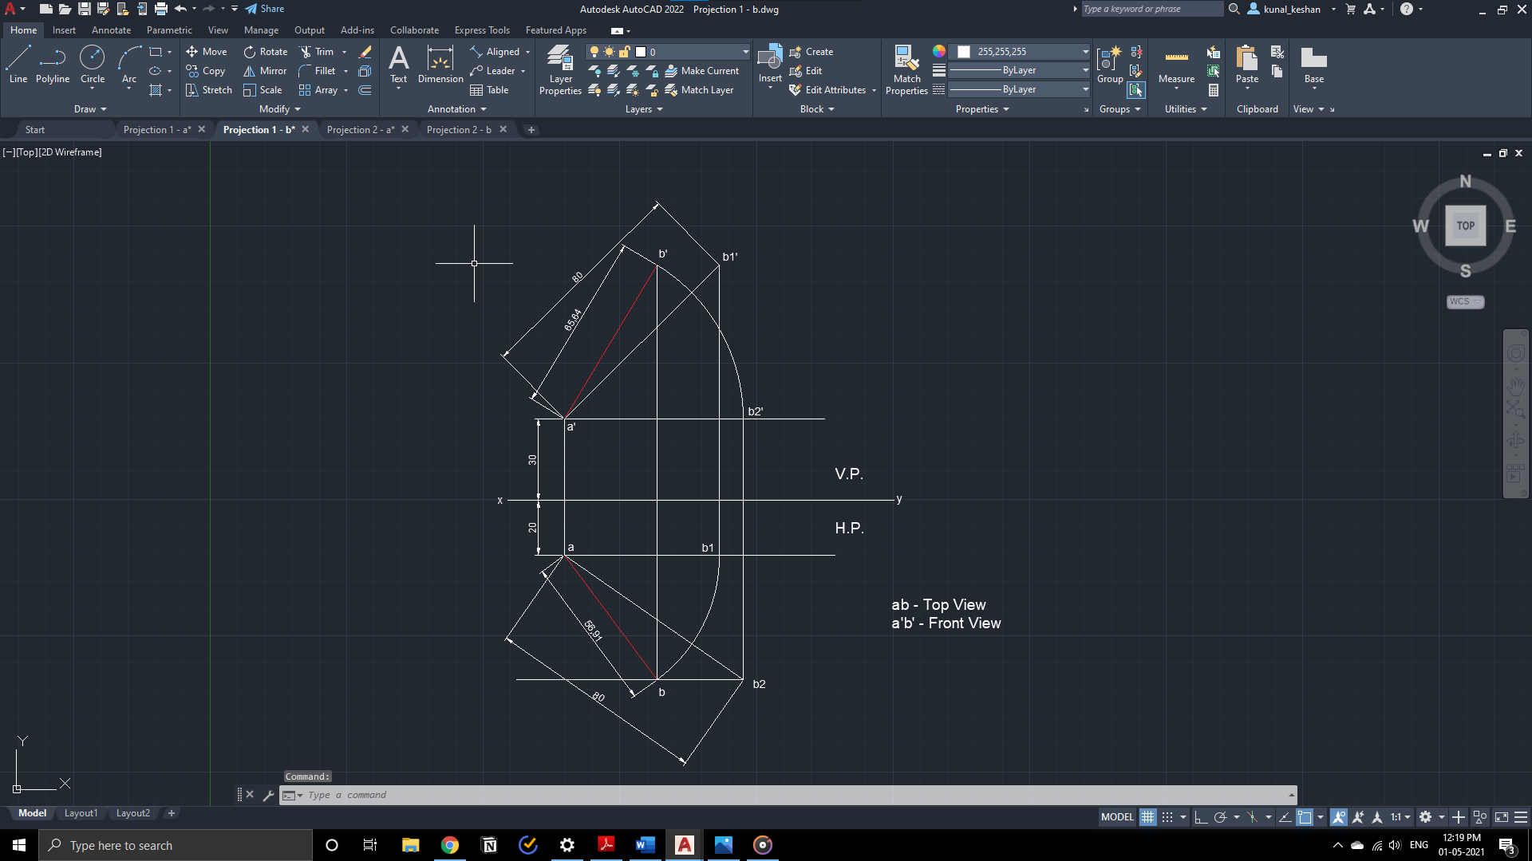

**Projection of Planes:**

**Questions 3:** A regular pentagon ABCDE, of side 25 mm has its side BC on floor. Its plane is perpendicular to floor and inclined at 45° to the wall. Draw the projections of the pentagon.

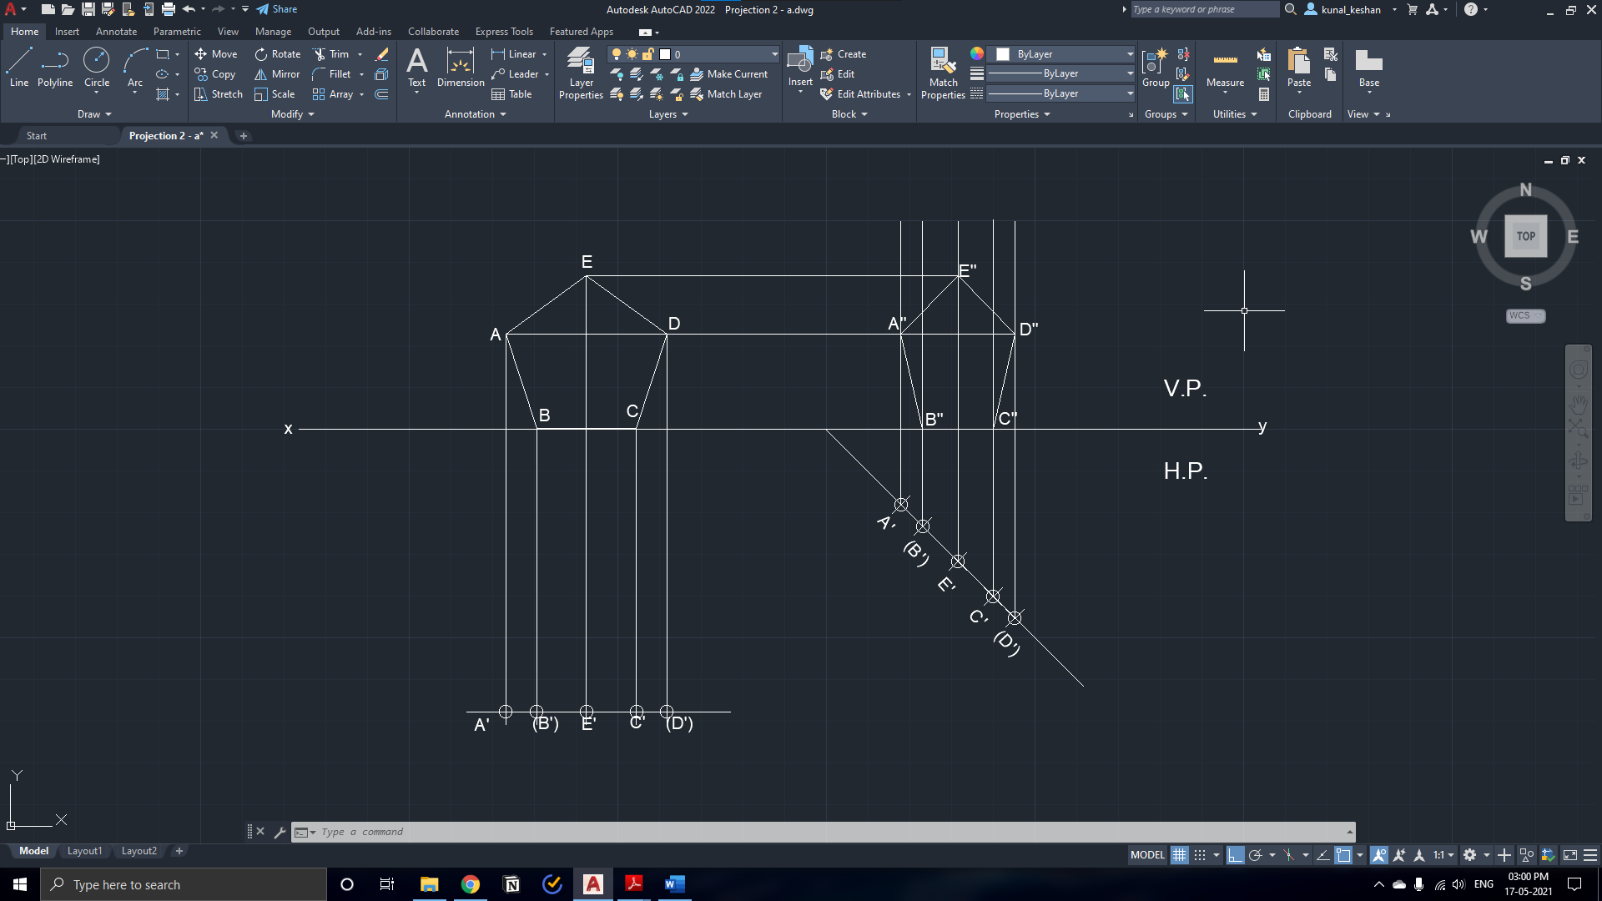

**Questions 4:** A regular hexagon ABCDEF of side 20 mm has its side DE on wall. Its plane is parallel to floor.

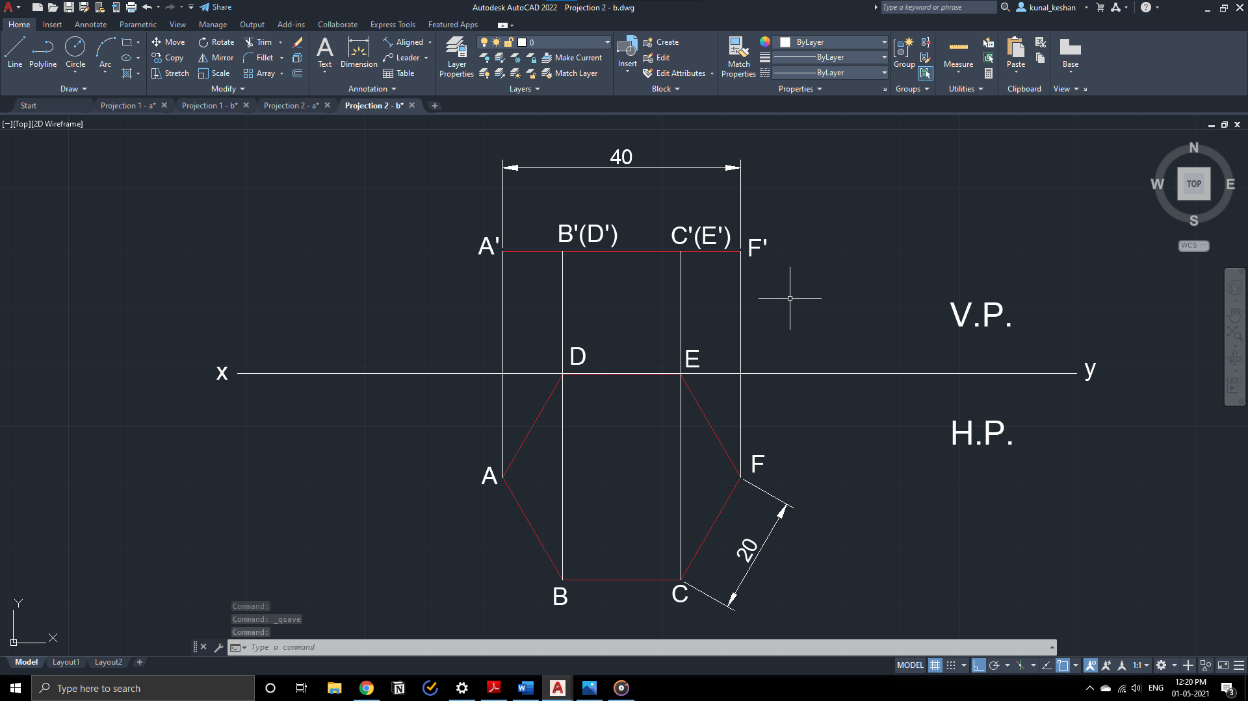

**Result:**

The orthographic multi-view projection of straight lines and planes have been drawn with the required dimensions.